**Worksheet – 1.2**

**Student Name: Ankit Kumar UID: 21MCA2139**

**Branch: MCA Section/Group: 7A**

**Semester: 3rd Date of Performance: 20-09-2022**

**Subject Name: Machine Learning LAB Subject Code: 21CAP-703**

1. **Aim/Overview of the practical:**

Write a program for sigmoid function, Linear regression using any dataset from kaggle

1. **Task to be done:**

Write a program for sigmoid function, Linear regression using any dataset from kaggle

1. **Code for experiment/practical:**

import matplotlib.pyplot as plt   
  
import numpy as np   
  
import math   
  
   
  
x = np.linspace(-10, 10, 100)   
  
z = 1/(1 + np.exp(-x))   
  
   
plt.plot(x, z)   
  
plt.xlabel("x")   
  
plt.ylabel("Sigmoid(X)")   
  
   
plt.show()

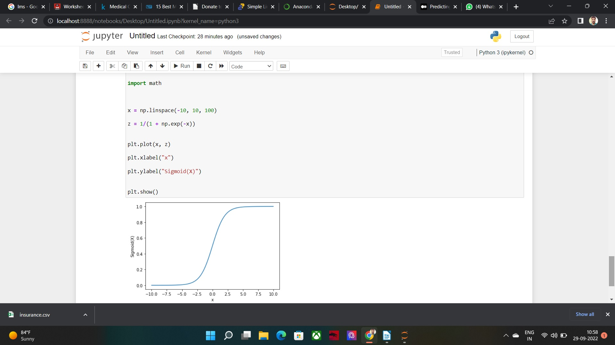

import numpy as np

import pandas as pd

import matplotlib.pyplot as plt

dataset = pd.read_csv('Salary_Data.csv')

dataset.head()

# data preprocessing

X = dataset.iloc[:, :-1].values #independent variable array

y = dataset.iloc[:,1].values #dependent variable vector

# splitting the dataset

from sklearn.model_selection import train_test_split

X_train, X_test, y_train, y_test = train_test_split(X,y,test_size=1/3,random_state=0)

# fitting the regression model

from sklearn.linear_model import LinearRegression

regressor = LinearRegression()

regressor.fit(X_train,y_train) #actually produces the linear eqn for the data

# predicting the test set results

y_pred = regressor.predict(X_test)

y_pred

y_test

# visualizing the results

#plot for the TRAIN

plt.scatter(X_train, y_train, color='red') # plotting the observation line

plt.plot(X_train, regressor.predict(X_train), color='blue') # plotting the regression line

plt.title("Salary vs Experience (Training set)") # stating the title of the graph

plt.xlabel("Years of experience") # adding the name of x-axis

plt.ylabel("Salaries") # adding the name of y-axis

plt.show() # specifies end of graph

#plot for the TEST

plt.scatter(X_test, y_test, color='red')

plt.plot(X_train, regressor.predict(X_train), color='blue') # plotting the regression line

plt.title("Salary vs Experience (Testing set)")

plt.xlabel("Years of experience")

plt.ylabel("Salaries")

plt.show()

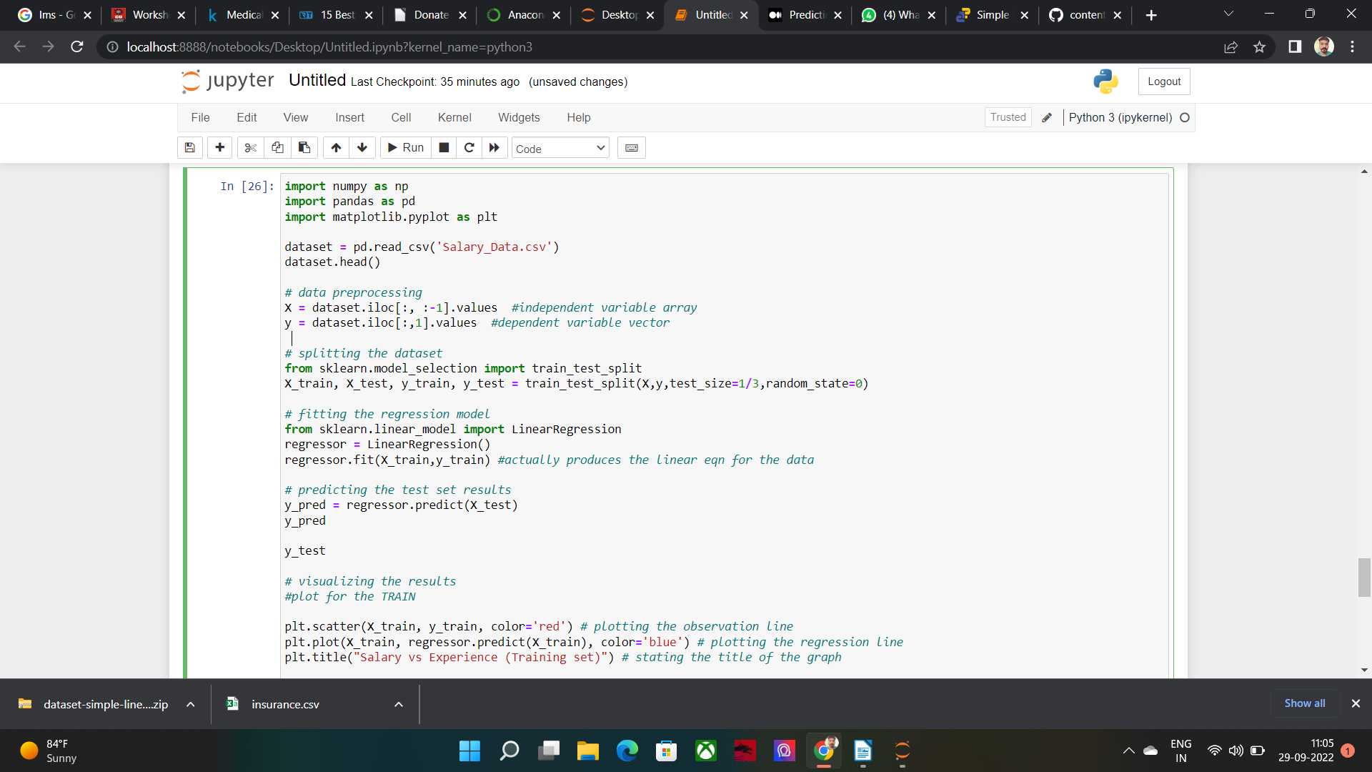

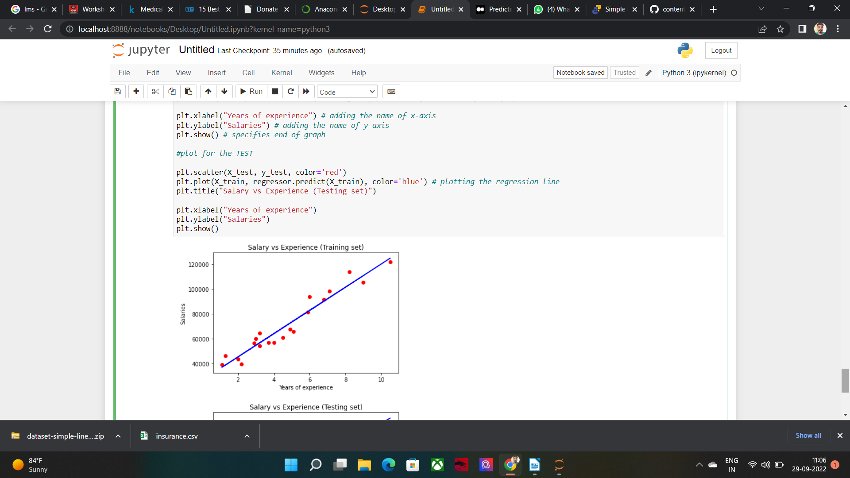

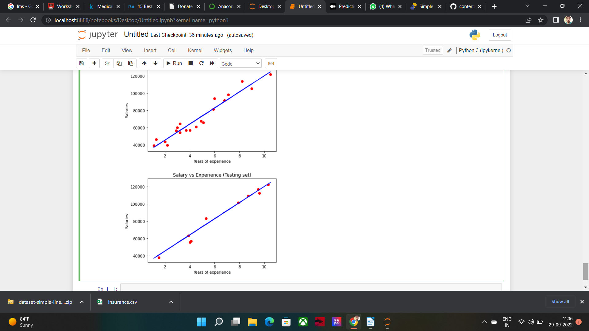

**Learning outcomes (What I have learnt):**

**2.** Also got familiar with the real-life use of machine learning.

**Evaluation Grid:**

|  |  |  |  |
| --- | --- | --- | --- |
| Sr. No. | Parameters | Marks Obtained | Maximum Marks |
| 1. | Demonstration and Performance |  | 5 |
| 2. | Worksheet |  | 10 |
| 3. | Post Lab Quiz |  | 5 |